Christmas Gift Baskets

November 13, 2019

Dear Parents/Guardians:

Royal Road Elementary School’s Home & School Association is getting ready for our Christmas fundraiser – Christmas Gift Baskets. Can you believe it’s that time of year already?

Each grade level will help to build a gift basket by bringing in items related to a theme, so we are asking families for donations. You may wish to donate individually or go together with another family to buy a larger item. We understand that this is a busy time of year, and you may find it easier to make a cash donation and we will purchase items.

If you could help contribute an item for the basket in your child’s grade, please send it to the school by Monday, December 2, 2019.

The baskets will be on display at the Christmas concert on Thursday, December 12th, and tickets will be on sale at that time. Tickets will also be sent home in case you aren’t able to make it to the concert. Photos of the baskets will be available on the school’s website.

The draw will be made on Thursday, December 12th after the concert.
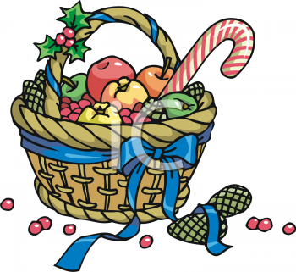
Thank you for your support! All proceeds will go towards purchasing equipment and materials for our children’s classrooms to enrich their learning experience.

Royal Road Home & School Association

2019 Annual Christmas Basket Fundraiser
Basket Theme | Grade | Suggestions for what to send in….
Toys/Games | K | From stores such as Toys R Us, Walmart, Costco……..
Gift card tree | 1 | From your favourite store…..!
Family Fun Night | 2 | Board games, card games, puzzles, dominos, crafts, movies, popcorn, popcorn flavouring, hot chocolate, cozy blanket….
Holiday Baking | 3 | Cookie cutters, baking pan, wooden spoon, whisk, measuring cups, fun bowls, apron, pot holder, frosting, sprinkles, cookie/cake mixes, choc. syrup, fluff, cook books…
Pets | 4 | Dog treats, cat treats, bones, toys, poop bags, shampoo, brush, towel, blanket, pet store gift card, anything to pamper your furry friend…
Bookworm | 5 | Book store gift certificates, books, chapter books, magazines, dictionary, thesaurus, flash cards, crosswords, word search, Sudoku, bookmarks, book lights, pens, pencils, highlighters, cool erasers, stapler, ruler, white-out, cozy blanket….

